LGB Policy and the Geography of Immigrants in Same-Sex Couples in the United States

Same-sex marriage and Migration Workshop in Amsterdam

Nathan I. Hoffmann, Department of Sociology, UCLA

Kristopher Velasco, Department of Sociology, Princeton University

August 30, 2024

Abstract

How do queer immigrants decide where to settle? The policy landscape for same-sex couples in the United States has changed rapidly in recent years, with immigrants being particularly affected. After the 2013 end of the Defense of Marriage Act, U.S. citizens could finally sponsor the visa of a same-sex partner. As previous work of ours has shown, in the wake of this policy change there has been a rapid increase of immigrants in same-sex couples, at least for those from progressive countries (Hoffmann & Velasco 2024). But little is known about where these immigrants choose to settle and enjoy their new rights. Do they gravitate toward queer-friendly cities and states, or are they more concerned with job opportunities or cost of living? How have these patterns changed over time, especially in response to local policy changes relevant to queer people and immigrants? Using American Community Survey data from 2008-2022, this paper will implement descriptive analyses and conditional logit models to study how settlement patterns of immigrants in same-sex couples in the U.S. respond to local and national policy changes as well as other local factors. These geographic measures will include the Human Rights Campaign’s Municipal Equality Index, Velasco’s LGBT Policy Index for U.S. states, and a host of other local measures such as housing prices, average income, queer density, and prevalence of immigrants from the same national origins.

# Introduction

In 2013, the U.S. Supreme Court overturned the Defense of Marriage Act and required the U.S. government to begin recognizing marriages between same-sex spouses. Among many consequences, this decision radically changed the immigration landscape: For the first time, same-sex spouses of U.S. citizens and lawful permanent residents were eligible to file a spousal petition for an immigrant visa (Edwards 2013). In the years since, the U.S. population of lesbian, gay, and bisexual (LGB) immigrants has grown rapidly. As Hoffmann and Velasco (2024) show, numbers of different-sex couples containing immigrants increased by 22 percent from 2008 to 2019 (from 7.8 million to 9.5 million), while those of corresponding same-sex couples grew by 140 percent in the same period (from 44 thousand to 107 thousand). Furthermore, Hoffmann and Velasco (2023) show that, compared to immigrants in different-sex couples, those in same-sex couples come from richer, more democratic, and more LGB-friendly countries that are less represented by immigrants in the U.S. They also tend to be more highly educated, work in more prestigious occupations, and have higher incomes. Hence, despite previous queer migration scholarship largely focusing on asylum seekers and others escaping repressive contexts, these migrants appear to be among the most well-off immigrants in the U.S.

Despite this work, little is known on *where* LGB migrants tend to settle after they arrive in the U.S. In the wake of the DOMA decision, where do these immigrants choose to settle and enjoy their new rights? Do they gravitate toward queer-friendly cities and states, or are they more concerned with job opportunities or cost of living? How have these patterns changed over time, especially in response to local policy changes relevant to queer people and immigrants? In their patterns of settlement, are LGB migrants more like migrants more broadly, or more like LGB Americans?

Using American Community Survey data from 2008-2022, this paper implements descriptive analyses and regression analyses to study how settlement patterns of immigrants in same-sex couples in the U.S. respond to local and national policy changes as well as other local factors. Findings suggest that LGB migrants are more similar to migrants than to LGB people who are not migrants. However, they tend to live in more advantaged areas than either group.

# Background

There is great interest in residential equity and the geographic distribution of people living in the United States. These spatial patterns are linked to a variety of important demographic and social outcomes like health and well-being, exposure to environmental and social hazards, access to quality of education, and social capital, among others. For immigrants, there is often an additional interest as variation in distribution can reveal the types and characteristics of immigrants entering the U.S. and indicate patterns of integration and assimilation into the dominant society. Questions of segregation are also relevant for native-born populations. This is especially true for LGBTQ+ populations as research consistently shows a concentration into neighborhood enclaves, i.e., “gayborhoods,” but this concentration is declining – perhaps indicating greater social acceptance as LGBTQ+ individuals integrate further other areas (**spring_2024_new?**). Here, we combine these two often distinct literatures, one on immigrant settlement patterns and the other on LGBTQ+ residential patterns, to understand where immigrants in same-sex relationships live in the United States. We focus on this new, burgeoning population as little prior work has been done in understanding these patterns (Hoffmann and Velasco 2023). Therefore, this lets us investigate whether the residential distribution of immigrants in same-sex couples adheres most similarly to their co-migrants or, instead, to their native-born counterparts.

## Immigrant Settlement in the United States

There is a long history in migration studies of explaining the settlement patterns of migrants. The theories of choice of destination within a country are similar to theories of migration more broadly. At one level, neoclassical economic theories predict that migrants will follow wage and unemployment differentials to places with high labor demand (Hatton and Williamson 2005; Todaro 1980). Newbold (1999) shows how these economic factors help explain settlement patterns in the U.S., also pointing to the importance of government welfare programs and the local immigration rate. This last effects highlights the importance of migrant networks that share information and resources to lower the cost of migration and settling in the destination (Massey et al. 1987). Relatedly, institutions that arise to recruit workers and ease entry and settlement can promote migration to particular destinations (Hernández-León 2013). Local political factors can also influence migrant settlement. For example, Watson (2013) shows that U.S. metropolitan areas that adopt 287(g) agreements – allowing local agencies to enforce Federal immigration law – see significantly greater propensity of immigrants to leave and relocate within the United States.

Settlement also varies by individual characteristics of immigrants. For Latino immigrants, South, Crowder, and Chavez (2005) find greater spatial assimilation – i.e., they are more likely to live among non-Hispanic White Americans – when they have greater human and economic capital and greater English proficiency. Iceland and Scopilliti (2008) find similar results for immigrants more broadly, with migrants more likely to live among the U.S.-born when they have been in the U.S. longer, have higher earnings, and own a home.

In recent years, scholars have turned to studying so called “new” immigrant destinations in the U.S. In the age of massive migration in the late 1800s and early 1900s, immigrants from Europe tended to settle in densely populated urban areas, especially major Eastern and Midwestern cities such as New York and Chicago. As the century progressed, migration from Europe was mostly cut off (Waldinger, Hoffmann, and Catron 2023; Zolberg 2008). As migration from Latin America increased, major cities along the border – especially in California and Texas – saw the greatest growth in migrants (Chiswick and Miller 2004). But in in a trend first noticed in the 1990s and early 2000s (Durand, Massey, and Charvet 2000; Singer 2004; Zúñiga and Hernández-León 2005; Massey 2008), migration to urban areas slowed and migrants relocated to rural areas and small towns in the Sun Belt and the Deep South. Flippen and Farrell-Bryan (2021) offer three explanations for this shift. First is an economic explanation: An overabundance of workers in traditional gateways – driven in part by mass legalization in the 1990s – resulted in excess labor supply, especially in California. At the same time, manufacturing and meat processing plants relocated to lower-wage, right-to-work states that were experiencing population growth and a demand for construction (Ribas 2015). Second, labor recruitment contributed to the movement of migrants from traditional areas to the new destinations, and migrant networks sustained the new migrant pathways (Stuesse 2016). Finally, increased immigration enforcement and hostile policies in the 1990s in border states such as California drove migrants further east (Durand and Massey 2019). Due to their lack of established migrant communities, dynamics of settlement differ in these new destinations: Comparing new and established migrant destinations, Hall (2013) finds greater segregation in new destinations, even when controlling for other local factors and individual characteristics.

## Distribution of Same-Sex Couples in the United States

Concerns of residential distribution, segregation, and equity have also been a prominent line of research for LGB populations in the U.S., generally, and same-sex couples, specifically. Similar to settlement patterns of migrants, LGB Americans are also influenced by the role of economic conditions in their settlement patterns. For example, those in same-sex couples are generally found to be in areas with greater socioeconomic conditions, like more college-educated individuals, higher property values, and access to greater local amenities (**florida_2003_cities?**; **black_2002_why?**; **lee_2018_health?**). These patterns reflect same-sex couples’ relatively higher discretionary income and ability to take advantage of local amenities and spend more on housing (**black_2002_why?**). Network effects appear to also be in play as a consistent finding shows that those in same-sex couples are often located in areas with high concentrations of other same-sex couples – similar to other ethnic and migrant enclaves. This clustering may help protect same-sex couples from violence and harassment (**hayslett_2011_out?**; **lee_2018_health?**). Because of this concentration, though, a significant amount of research on residential patterns of same-sex couples focuses on their relative concentration in particular urban gayborhoods (**ghaziani_2016_there?**). By extension, this urban-focused set of research looks at transformations of gayborhoods and changes in sexuality-based residential segregation (**ghaziani_2016_there?**; **spring_2024_new?**). Finally, one distinct characteristic is the role of progressive policies like same-sex marriage and non-discrimination protections in influencing attitudes toward migration and actual migration practices (**baumle_2023_effects?**). Marcén and Morales (2022) finds that the legalization of same-sex marriage across U.S. states led to an increase in same-sex couples moving to those states, but only for men in such couples.

Combined, these trends have often emphasized same-sex couples living in urban gayborhoods with access to (relatively) more progressive legal environments. But, both changes in demographic trends and academic attention have shifted greater attention to LGB individuals and same-sex couples living beyond these particular locales. From 2000 to 2010 and then continuing to 2020, the concentration of same-sex couples into their own segregated, urban communities has declined (**spring_2013_declining?**; **spring_2024_new?**). These trends have invited additional research to understand the spread of same-sex couples into suburban and rural localities. For example, some find same-sex couples to leave urban centers due to rising housing values, patterns of poverty, and discriminatory lending practices encourage dispersion of the population (**spring_2024_new?**). These trends also underscore the argument made by (**stone_2018_the?**) that researchers of LGBTQ+ geography need to look beyond the “great cities” and toward more ordinary citiies, the South, and rural locals. Indeed, same-sex couples’ increased representation within red states and rural counties may underscore the increased acceptance and social integration of these unions (**marino_2024_visualizing?**).

Unfortunately, data on LGBTQ+ residential location in the United States is quite limited. Reliance on data from the decennial census and the American Community Survey have necessarily constrained insights to those in cohabiting, same-sex couples. There has also been a bias to examine only urban residential patterns, despite increased settlement into suburban and rural locations (**marino_2024_visualizing?**). More research is needed, then, to understand patterns at lower levels of aggregation (**spring_2024_new?**). Additionally, this research on same-sex couples typically assumes all respondents are native-born Americans. Consequently, it is unknown whether the patterns exhibited here are in any way reflective of immigrants in similar unions. Because Hoffmann and Velasco (2024) find immigrants in same-sex couples to be of relatively more privileged socioeconomic status compared to immigrants in different-sex couples, it is possible these immigrants may be settled in patterns more reflective of their native LGB counterparts than their fellow immigrants. Considering that a key driver of immigrants in same-sex couples is through mixed-status marriages after DOMA (Hoffmann and Velasco 2024), it likely means settlement patterns are more similar to native-born LGB individuals.

# Data and Methods

Our main source of data is the American Community Survey (ACS) for 2008 to 2022 (except for 2020, when data quality was not of adequate quality) (Ruggles et al. 2024). Each year, the ACS surveys a 1-percent representative sample of U.S. households about their education, occupation, income, family structure, immigration status, country of origin, location, and a variety of other individual and household attributes. We define a same-sex couple as two individuals of the same sex in the same household who report their relationship as “spouse” or “unmarried partner.” We limit the sample to individuals age 18 to 64, and immigrants in the sample migrated at the age of 18 or older.

We consider the spatial distribution of three groups: immigrants in same-sex couples (unweighted $N$ = 13,284), immigrants in different-sex couples ( $N$ = 1,575,975), and individuals in same-sex couples where neither individual is an immigrant ( $N$ = 173,546). The weighted sample is equivalent to 1.9e+08 individuals over the 14 years of data.

We use “LGB” to refer to all individuals who may be in romantic relationships with members of the same sex, although we recognize that some individuals in same-sex relationships may not identify as lesbian, gay, or bisexual. We also recognize that we are not able to identify bisexual (or pansexual, multisexual, etc.) individuals cohabiting with different-sex partners. Furthermore, measuring the prevalence of same-sex couples in the U.S. is difficult (Michaels 2013). As in most nationally representative demographic work on same-sex couples (Baumle 2013; Baumle and Dreon 2019), we are able to identify only LGB couples that cohabit; unpartnered LGB individuals and those who do not live with their partner are not included in the analysis (Baumle, Compton, and Poston 2009, 6). In addition, LGB individuals who do not feel comfortable with the partner labels of the ACS are not in the sample. Another pitfall is measurement error: Misreporting may result when different-sex couples accidentally misspecify the gender of one of the partners (Gates and Steinberger 2009; Goodnature and Neto 2021). Beginning in 2008, the Census Bureau made changes to ACS gender and partnership questions in order to prevent such errors (U.S. Census Bureau 2013), so we rely on data only from 2008 onward, but difficulties remain. If even a small number of different-sex couples misreport one partner’s sex, the counts of same-sex couples will be inflated. Following Gates and Steinberger (2009), we remove all respondents that had either their relationship or sex variable allocated by the Census Bureau. This is the strategy used by most studies of same-sex couples in the ACS (e.g. Boertien and Vignoli 2019; Gates 2013; Goldberg and Conron 2021; Christafore and Leguizamon 2019; Martell and Nash 2020).

## Variables

Most of our variables come from the ACS and are calculated at the level of the Public Use Microdata Area (PUMA), a geographic unit of analysis that covers a population of at least 100,000 and does not cross state lines. PUMAs partition the entirety of the United States, and most of our analyses are at the level of the country as a whole.

We consider a variety of social, economic, and spatial variables at the PUMA level in the ACS. The first set of variables are the percentage of individuals in the PUMA with the following characteristics: who hold at least a bachelor’s degree, who identify as Black, who identify as Hispanic, who own their own home, who are immigrants (born outside the U.S.), whose income is under 100% or 200% of the poverty line, and who are unemployed. Next are the mean PUMA-level values of personal income, age, Hauser-Warren occupational prestige score (HWSEI, Hauser and Warren 1997), value of home (in $1000s), rent, and cost of electricity. We also use a measure of density of the PUMA in persons per square mile.

We also use data from two other sources. First, to examine LGB policies at state of destination, we use original datasets. To create the U.S. state policy index, we compile data from the Movement Advancement Project[1], a leading LGB organization in the U.S. that collects data on a number of relevant policies. A higher score represents more progress state-level policies. Progressive policies include full marriage equality, state recognition of civil unions and domestic partnerships, ban on all employment and housing discrimination based on sexual orientation, hate crime protections based on sexual orientation, legal joint adoption by same-sex couples, and a ban on conversation therapy for minors. For regressive policies, we consider criminalization of sodomy, state constitutional bans of marriage equality, religious freedom exemptions to discriminate against same-sex couples in adoption, and state-level bans on local non-discrimination ordinances encompassing sexual orientation. The state index ranges from -2 to 7, and the mean state policy score in this time period is 3.4.

Our second outside data source is a measure of the prevalence of LGBTQ+ and immigrant-serving nonprofits in a given PUMA. These data come from the Internal Revenue Service’s Business Master File (BMF). The BMF collects basic, administrative data on all tax-exempt entities required to submit a Form 990 annually. For our purposes, we restrict our sample to just 501c(3) charitable organizations. Additionally, the IRS assigns each organization an activity code from the National Taxonomy of Exempt Entities (NTEE). These NTEE codes help designate whether an organization is focused on “Arts & Culture” (code: A20) or “Homeless Shelters” (code: L82). We classify nonprofits with NTEE codes “Ethnic & Immigrant Centers (code: P84) and”Immigrant Rights” (code: R21) as immigrant serving. While LGBTQ+ nonprofits are those designed as “LGBT Centers” (code: P88) and “Lesbian & Gay Rights” (code: R26). We additionally supplement our classification of LGBTQ+ nonprofits with those used by (**velasco_2023_deconstructed?**), who found LGBTQ+ nonprofits operating under other classification designations.

Means for all of these variables by group are presented in Table 1.

## Analytic Strategy

Many of our analyses entail descriptive statistics of ACS data. For these and for the reshaping described below, we apply survey weights from the ACS.

For the next stage of the analysis, we use OLS models. One of our goals is to isolate the effect of country-of-origin LGB policy on the immigration of immigrants in same-sex couples. The ideal survey would follow potential immigrants over time and have information about sexual orientation, allowing us to estimate how choice of residence varies by sexual orientation. This ideal dataset does not exist, but we attempt to approximate it. First, to study how different LGB migrants are from straight ones, we reshape the data so that each observation is the percentage of individual cohabiting immigrants in same-sex couples in PUMA $x$ in survey year $y$, out of all cohabiting immigrants in that PUMA. We regress the resulting percentage on the set of variables discussed above, adding state and year fixed effects and clustering errors at the state and year levels. We then repeat this analysis, but with the aim of determining how different LGB migrants are from LGB non-migrants. We reshape the data so that each observation is the percentage of immigrants in same-sex couples *out of all same-sex couples*, in PUMA $x$ in survey year $y$.

# Results

## Descriptive Results

To show broadly how the geography of immigrants in same-sex couples has changed over the past 15 years, Figure 1 presents the percentage coupled immigrants in each state who are in same-sex couples and how these figures have changed over time. The figure shows maps for three time periods: 2008-2012, 2013-2017, and 2018-2022. Most states had greater proportions of immigrants in same-sex couples in 2022 than in 2008. In addition, the pattern of growth is meaningful. Shortly after the end of the Defense of Marriage Act in 2013 – when U.S. citizens and permanent residents could finally sponsor the visa of a same-sex partner – their growth was concentrated in the Northeast, where states were relatively early adopters of same-sex marriage, including Massachusetts (2004), Connecticut (2008), Vermont (2009), New Hampshire (2010), New York (2011), Maine (2012), and Maryland (2013). However, in the next period (2018-2022), more of the map shows higher percentages of immigrants in same-sex couples, including more relatively conservative states.

Table 1 presents descriptive statistics for PUMA-level characteristics, separated by the three groups of interest: immigrants in different-sex couples, immigrants in same-sex couples, and non-immigrants partnered with same-sex non-immigrants. In the table, all variables are averaged over the full range of survey years. Immigrants in same-sex couples tend to be more similar to immigrants in different-sex couples than non-immigrants in same-sex couples. Most notably, immigrants in same- and different-sex couples live in areas with similar proportions of immigrants and Hispanic people, with higher home values and rent, and in denser areas. However, immigrants in same-sex couples live in areas with somewhat more advantage than the other two groups. They live in areas with higher incomes and higher occupational prestige, and the home and rent prices of their areas are somewhat higher than those of immigrants more broadly. They also live in denser areas.

Clear differences also arise around two variables relevant to queer people. First, although all three groups tend to live in relatively progressive states with a score of at least 3, immigrants in same-sex couples live in states with an average score of nearly 4. Also notable are differences around the number of LGBT nonprofits. On average, immigrants in same-sex couples live in PUMAs with 1.2 LGBT nonprofits, while LGB non-immigrants live in PUMAs with 0.76 and immigrants in different-sex couples with 0.30. They also live in areas with more immigrant nonprofits, with an average of 1.0. Surprisingly, the number of immigrant nonprofits for the average immigrant in a different-sex couple and average non-immigrant in a same sex couple are quite similar, at about 0.8.

Figures 2 and 3 show how these differences are fairly stable over time. One notable change is the average percent of Black residents in the typical area for each group: Around 2010, immigrants in same-sex couples were 1 to 2 percentage points more likely to live in areas with Black respondents than the other groups, but in recent years the numbers are very similar.

## Models

Table 2 presents OLS regressions for the percentage of immigrants in same-sex couples, out of all immigrants in couples, at the PUMA level. Model 1 does not include fixed effects, Model 2 includes state fixed effects and errors clustered at the state level, and Model 3 includes both state and year fixed effects and clusters errors at the state and year levels. Model 3 shows that a number of factors remain significant even in models with these fixed effects. Areas are more likely to have higher proportions of immigrants in same-sex couples (out of all coupled immigrants) if fewer people own their own home, the average age is higher, the percentage of immigrants is lower, more people are above the poverty line, homes are worth somewhat less, the number of LGBT nonprofits is higher, and the number of immigrant nonprofits is lower.

Table 3 presents corresponding regressions for the proportion of all people in same-sex couples who are immigrants. Again, a number of coefficients are significant in Model 3, which includes state and year fixed effects. Compared to LGB individuals more broadly, LGB immigrants tend to live in areas with more Black and Hispanic people, lower income, more people who own their own home, higher percentages of immigrants, higher home prices greater density, and with fewer immigrant nonprofits.

# Discussion and Conclusion

# References

Baumle, Amanda K., ed. 2013. *International Handbook on the Demography of Sexuality*. Vol. 5. International Handbooks of Population. Dordrecht: Springer Netherlands. <https://doi.org/10.1007/978-94-007-5512-3>.

Baumle, Amanda K., D’Lane Compton, and Dudley L. Poston. 2009. *Same-Sex Partners: The Social Demography of Sexual Orientation*. SUNY Press.

Baumle, Amanda K., and Ben Dreon. 2019. “The Demography of Sexuality.” In *Handbook of Population*, edited by Dudley L. Poston Jr., 279–88. Handbooks of Sociology and Social Research. Cham: Springer International Publishing. <https://doi.org/10.1007/978-3-030-10910-3_11>.

Boertien, Diederik, and Daniele Vignoli. 2019. “Legalizing Same-Sex Marriage Matters for the Subjective Well-Being of Individuals in Same-Sex Unions.” *Demography* 56 (6): 2109–21.

Chiswick, Barry R., and Paul W. Miller. 2004. “Where Immigrants Settle in the United States.” *Journal of Comparative Policy Analysis: Research and Practice* 6 (2): 185–97. <https://doi.org/10.1080/1387698042000273479>.

Christafore, David, and Susane Leguizamon. 2019. “Taste-Based Discrimination, Tolerance and the Wage Gap: When Does Economic Freedom Help Gay Men?” *Kyklos : Jahrbuch Des Instituts für Geschichte Der Medizin an Der Universität Leipzig* 72 (3): 426–45. <https://doi.org/10.1111/kykl.12206>.

Durand, Jorge, and Douglas S. Massey. 2019. “Evolution of the Mexico-U.S. Migration System: Insights from the Mexican Migration Project.” *The ANNALS of the American Academy of Political and Social Science* 684 (1): 21–42. <https://doi.org/10.1177/0002716219857667>.

Durand, Jorge, Douglas S. Massey, and Fernando Charvet. 2000. “The Changing Geography of Mexican Immigration to the United States: 1910-1996.” *Social Science Quarterly* 81 (1): 1–15. <https://www.jstor.org/stable/42864364>.

Edwards, Benjamin P. 2013. “Welcoming a Post-DOMA World: Same-Sex Spousal Petitions and Other Post-Windsor Immigration Implications.” *Family Law Quarterly* 47 (2): 173–89.

Flippen, Chenoa A., and Dylan Farrell-Bryan. 2021. “New Destinations and the Changing Geography of Immigrant Incorporation.” *Annual Review of Sociology* 47 (1): null. <https://doi.org/10.1146/annurev-soc-090320-100926>.

Gates, Gary J. 2013. “LGBT Adult Immigrants in the United States.” UCLA: The Williams Institute.

Gates, Gary J., and Michael D. Steinberger. 2009. “Same-Sex Unmarried Partner Couples in the American Community Survey: The Role of Misreporting, Miscoding and Misallocation.” In *Annual Meetings of the Population Association of America, Detroit, MI*.

Goldberg, Shoshana K., and Kerith J. Conron. 2021. “LGBT Adult Immigrants in the United States.” UCLA: The Williams Institute.

Goodnature, Mia, and Amir B. Ferreira Neto. 2021. “Same-Sex Unmarried Partners in the Census.” *Journal of Regional Analysis & Policy* 51 (1): 43–66.

Hall, Matthew. 2013. “Residential Integration on the New Frontier: Immigrant Segregation in Established and New Destinations.” *Demography* 50 (5): 1873–96. <https://doi.org/10.1007/s13524-012-0177-x>.

Hatton, Timothy J., and Jeffrey G. Williamson. 2005. *Global Migration and the World Economy: Two Centuries of Policy and Performance*. The MIT Press. <https://doi.org/10.7551/mitpress/3303.001.0001>.

Hauser, Robert M., and John Robert Warren. 1997. “Socioeconomic Indexes for Occupations: A Review, Update, and Critique.” *Sociological Methodology* 27: 177–298. <https://www.jstor.org/stable/271107>.

Hernández-León, Rubén. 2013. “Conceptualizing the Migration Industry.” In *The Migration Industry and the Commercialization of International Migration*, edited by Thomas Gammeltoft-Hansen and Ninna Nyberg Sorensen, 42–62. Routledge.

Hoffmann, Nathan I., and Kristopher Velasco. 2023. “Sexuality, Migration, and LGB Policy: A Portrait of Immigrants in Same-Sex Couples in the United States.” *International Migration Review*, August, 01979183231187623. <https://doi.org/10.1177/01979183231187623>.

———. 2024. “Policy Effects on Mixed-Citizenship, Same-Sex Unions: A Triple-Difference Analysis.” *Social Forces* 102 (3): 1134–56. <https://doi.org/10.1093/sf/soad108>.

Iceland, John, and Melissa Scopilliti. 2008. “Immigrant Residential Segregation in U.S. Metropolitan Areas, 1990–2000.” *Demography* 45 (1): 79–94. <https://doi.org/10.1353/dem.2008.0009>.

Marcén, Miriam, and Marina Morales. 2022. “The Effect of Same-Sex Marriage Legalization on Interstate Migration in the USA.” *Journal of Population Economics* 35 (2): 441–69. <https://doi.org/10.1007/s00148-021-00842-5>.

Martell, Michael E., and Peyton Nash. 2020. “For Love and Money? Earnings and Marriage Among Same-Sex Couples.” *Journal of Labor Research* 41 (3): 260–94. <https://doi.org/10.1007/s12122-020-09305-4>.

Massey, Douglas S., ed. 2008. *New Faces in New Places: The Changing Geography of American Immigration*. New York, NY: Russell Sage Foundation.

Massey, Douglas S., Rafael Alarcon, Jorge Durand, and Humberto González. 1987. *Return to Aztlan: The Social Process of International Migration from Western Mexico*. Berkeley: University of California Press.

Michaels, Stuart. 2013. “Sexual Behavior and Practices: Data and Measurement.” In *International Handbook on the Demography of Sexuality*, 11–20. Springer.

Newbold, K. Bruce. 1999. “Spatial Distribution and Redistribution of Immigrants in the Metropolitan United States, 1980 and 1990*.” *Economic Geography* 75 (3): 254–71. <https://doi.org/10.1111/j.1944-8287.1999.tb00079.x>.

Ribas, Vanesa. 2015. *On the Line: Slaughterhouse Lives and the Making of the New South*. First edition. Oakland, California: University of California Press.

Ruggles, Steven, Sarah Flood, Sophia Foster, Ronald Goeken, Jose Pacas, Megan Schouweiler, and Matthew Sobek. 2024. “IPUMS USA: Version 15.0 American Community Survey 2008-2022.” Minneapolis, MN: IPUMS.

Singer, Audrey. 2004. “The Rise of New Immigrant Gateways.” Washington, D.C.: The Brookings Institution.

South, Scott J., Kyle Crowder, and Erick Chavez. 2005. “Migration and Spatial Assimilation Among U.S. Latinos: Classical Versus Segmented Trajectories.” *Demography* 42 (3): 497–521. <https://doi.org/10.1353/dem.2005.0025>.

Stuesse, Angela. 2016. *Scratching Out a Living: Latinos, Race, and Work in the Deep South*. First edition. Oakland, California: University of California Press.

Todaro, Michael. 1980. “Internal Migration in Developing Countries: A Survey.” In *Population and Economic Change in Developing Countries*, 361–402. Chicago: University of Chicago Press.

U.S. Census Bureau. 2013. “Frequently Asked Questions About Same-Sex Couple Households.” U.S. Census Bureau Fertility and Family Statistics Branch.

Waldinger, Roger, Nathan I. Hoffmann, and Peter Catron. 2023. “Impeding Access: Immigrants and Naturalization in Early Twentieth-Century America.” OSF. <https://doi.org/10.31235/osf.io/6wx2h>.

Watson, Tara. 2013. “Enforcement and Immigrant Location Choice.” Working {{Paper}}. Working Paper Series. National Bureau of Economic Research. <https://doi.org/10.3386/w19626>.

Zolberg, Aristide R. 2008. *A Nation by Design: Immigration Policy in the Fashioning of America*. New York, NY: Harvard University Press.

Zúñiga, Victor, and Rubén Hernández-León, eds. 2005. *New Destinations: Mexican Immigration in the United States*. Illustrated edition. New York, NY: Russell Sage Foundation.

# Tables

Table 1: Mean values for geographic variables for immigrants in different- or same-sex couples, 2008-2022

| Variable | Different-sex, immigrant | Same-sex, immigrant | Same-sex, non-immigrant |
| --- | --- | --- | --- |
| Bachelor's degree (%) | 22.73 | 25.4 | 23.53 |
| Black (%) | 12.60 | 12.9 | 12.75 |
| Hispanic (%) | 24.49 | 23.6 | 16.62 |
| Mean personal income | 27.48 | 29.5 | 27.93 |
| Individuals own home (%) | 61.25 | 58.6 | 62.82 |
| Mean age | 37.71 | 38.4 | 38.48 |
| Immigrant (%) | 20.44 | 20.0 | 13.47 |
| Individuals under 100% of poverty line (%) | 12.62 | 12.4 | 12.23 |
| Individuals under 200% of poverty line (%) | 29.77 | 28.8 | 28.63 |
| Mean HWSEI occupation score | 36.97 | 37.7 | 37.29 |
| Unemployed (%) | 2.63 | 2.5 | 2.44 |
| Mean individual's value of home ($1000s) | 4,111.50 | 4,398.7 | 3,938.43 |
| Mean individual's rent | 406.61 | 481.7 | 363.84 |
| Mean cost of electricity | 2,181.30 | 2,237.4 | 2,200.92 |
| density | 8,144.18 | 11,628.1 | 6,088.93 |
| State LGB policy score | 3.39 | 3.9 | 3.14 |
| Mean number of LGBT nonprofits | 0.30 | 1.2 | 0.76 |
| Mean number of immigrant nonprofits | 0.79 | 1.0 | 0.82 |
| n | 1,575,975 | 13,284 | 173,546 |
| n_weighted | 175,419,016 | 1,322,217 | 16,358,472 |

Table 2: Proportion of immigrants in same-sex couples by PUMA, regressed on PUMA-level factors

|  |  |  |  |
| --- | --- | --- | --- |
|  | (1) | (2) | (3) |
| Bachelor's degree (%) | 0.011 † | 0.020 † | 0.016 † |
|  | (0.007) | (0.012) | (0.010) |
| Black (%) | 0.002 | 0.001 | -0.000 |
|  | (0.001) | (0.002) | (0.002) |
| Hispanic (%) | 0.006 *** | 0.004 * | 0.002 |
|  | (0.002) | (0.002) | (0.002) |
| Log mean personal income | -0.584 ** | -0.292 | 0.114 |
|  | (0.214) | (0.196) | (0.209) |
| Individuals own home (%) | -0.062 ** | -0.065 * | -0.085 * |
|  | (0.022) | (0.027) | (0.033) |
| Mean age | 0.082 *** | 0.059 *** | 0.045 *** |
|  | (0.007) | (0.009) | (0.013) |
| Immigrant (%) | -0.032 *** | -0.036 *** | -0.033 *** |
|  | (0.003) | (0.005) | (0.006) |
| Individuals under 200% of poverty line (%) | 0.734 † | 0.901 * | 1.104 ** |
|  | (0.419) | (0.359) | (0.337) |
| Mean HWSEI occupation score | 0.031 † | -0.004 | -0.009 |
|  | (0.017) | (0.027) | (0.028) |
| Unemployed (%) | -0.040 * | -0.006 | 0.019 |
|  | (0.016) | (0.017) | (0.024) |
| Mean individual's value of home ($1000s) | -0.000 ** | -0.000 * | -0.000 * |
|  | (0.000) | (0.000) | (0.000) |
| Mean individual's rent | 0.002 *** | 0.001 *** | 0.001 ** |
|  | (0.000) | (0.000) | (0.000) |
| Mean cost of electricity | 0.000 * | -0.000 | -0.000 |
|  | (0.000) | (0.000) | (0.000) |
| Density (persons per sq. mile) | 0.000 | -0.000 | 0.000 |
|  | (0.000) | (0.000) | (0.000) |
| State LGB policy score | 0.087 *** | 0.175 *** | 0.024 |
|  | (0.009) | (0.030) | (0.031) |
| Mean number of LGBT nonprofits | 0.190 *** | 0.176 *** | 0.182 ** |
|  | (0.018) | (0.053) | (0.060) |
| Mean number of immigrant nonprofits | -0.049 ** | -0.041 ** | -0.042 *** |
|  | (0.016) | (0.014) | (0.011) |
| State FEs and clustered errors? | no | yes | yes |
| Year FEs and clustered errors? | no | no | yes |
| Observations | 31725 | 31725 | 31725 |
| *** p < 0.001; ** p < 0.01; * p < 0.05; † p < 0.1. | | | |

Table 3: Proportion of same-sex partnered people who are immigrants by PUMA, regressed on PUMA-level factors

|  |  |  |  |
| --- | --- | --- | --- |
|  | (1) | (2) | (3) |
| Bachelor's degree (%) | -0.095 * | -0.099 | -0.101 |
|  | (0.043) | (0.056) | (0.080) |
| Black (%) | 0.046 *** | 0.042 * | 0.041 * |
|  | (0.009) | (0.017) | (0.018) |
| Hispanic (%) | 0.051 *** | 0.092 *** | 0.090 ** |
|  | (0.011) | (0.025) | (0.029) |
| Log mean personal income | -5.959 *** | -5.589 * | -5.374 * |
|  | (1.337) | (2.177) | (2.410) |
| Individuals own home (%) | 0.517 *** | 0.634 *** | 0.623 * |
|  | (0.137) | (0.183) | (0.247) |
| Mean age | 0.264 *** | 0.166 | 0.159 |
|  | (0.044) | (0.085) | (0.092) |
| Immigrant (%) | 0.547 *** | 0.486 *** | 0.488 *** |
|  | (0.018) | (0.062) | (0.060) |
| Individuals under 200% of poverty line (%) | -3.568 | -1.117 | -1.016 |
|  | (2.643) | (3.436) | (3.825) |
| Mean HWSEI occupation score | 0.248 * | 0.334 | 0.331 |
|  | (0.110) | (0.220) | (0.213) |
| Unemployed (%) | -0.322 ** | -0.352 | -0.338 |
|  | (0.102) | (0.199) | (0.199) |
| Mean individual's value of home ($1000s) | 0.000 ** | 0.000 ** | 0.000 * |
|  | (0.000) | (0.000) | (0.000) |
| Mean individual's rent | 0.003 * | 0.004 * | 0.004 |
|  | (0.001) | (0.002) | (0.002) |
| Mean cost of electricity | 0.000 | -0.000 | -0.000 |
|  | (0.000) | (0.000) | (0.000) |
| Density (persons per sq. mile) | 0.000 *** | 0.000 * | 0.000 * |
|  | (0.000) | (0.000) | (0.000) |
| State LGB policy score | 0.206 *** | 0.209 | 0.132 |
|  | (0.058) | (0.111) | (0.136) |
| Mean number of LGBT nonprofits | -0.004 | -0.048 | -0.046 |
|  | (0.106) | (0.133) | (0.126) |
| Mean number of immigrant nonprofits | -0.310 ** | -0.265 *** | -0.266 *** |
|  | (0.097) | (0.073) | (0.074) |
| State FEs and clustered errors? | no | yes | yes |
| Year FEs and clustered errors? | no | no | yes |
| Observations | 28175 | 28175 | 28175 |
| *** p < 0.001; ** p < 0.01; * p < 0.05. | | | |

Table 4: Quasi-poisson models by PUMA, regressed on PUMA-level factors, separately by group

|  |  |  |  |
| --- | --- | --- | --- |
|  | Different-sex, immigrant | Same-sex, immigrant | Same-sex, non-immigrant |
| Bachelor's degree (%) | 0.005 | 0.018 *** | 0.022 *** |
|  | (0.006) | (0.004) | (0.004) |
| Black (%) | 0.001 | 0.005 ** | -0.001 |
|  | (0.001) | (0.002) | (0.001) |
| Hispanic (%) | -0.001 | 0.007 *** | 0.001 |
|  | (0.003) | (0.001) | (0.001) |
| Log mean personal income | 0.795 *** | 1.039 *** | 0.693 *** |
|  | (0.156) | (0.208) | (0.162) |
| Individuals own home (%) | -0.030 ** | -0.086 *** | -0.093 *** |
|  | (0.012) | (0.014) | (0.012) |
| Mean age | -0.069 *** | 0.001 | -0.001 |
|  | (0.006) | (0.015) | (0.011) |
| Immigrant (%) | 0.048 *** | 0.016 *** | -0.018 *** |
|  | (0.004) | (0.002) | (0.002) |
| Individuals under 200% of poverty line (%) | 0.244 | 0.728 *** | 0.120 |
|  | (0.230) | (0.210) | (0.236) |
| Mean HWSEI occupation score | 0.006 | -0.001 | -0.002 |
|  | (0.020) | (0.010) | (0.008) |
| Unemployed (%) | 0.022 *** | 0.049 ** | 0.055 *** |
|  | (0.006) | (0.019) | (0.016) |
| Mean individual's value of home ($1000s) | -0.000 ** | -0.000 *** | -0.000 *** |
|  | (0.000) | (0.000) | (0.000) |
| Mean individual's rent | -0.000 * | -0.000 | -0.000 * |
|  | (0.000) | (0.000) | (0.000) |
| Mean cost of electricity | -0.000 | -0.000 *** | -0.000 *** |
|  | (0.000) | (0.000) | (0.000) |
| Density (persons per sq. mile) | 0.000 | 0.000 † | 0.000 |
|  | (0.000) | (0.000) | (0.000) |
| State LGB policy score | 0.009 | 0.047 *** | 0.012 |
|  | (0.007) | (0.012) | (0.016) |
| Mean number of LGBT nonprofits | -0.023 *** | 0.033 ** | 0.033 ** |
|  | (0.006) | (0.012) | (0.013) |
| Mean number of immigrant nonprofits | 0.015 *** | -0.009 | 0.008 |
|  | (0.004) | (0.009) | (0.012) |
| N | 31826 | 31826 | 31826 |
| logLik |  |  |  |
| State FEs and clustered errors? | yes | yes | yes |
| Year FEs and clustered errors? | yes | yes | yes |
| AIC |  |  |  |
| *** p < 0.001; ** p < 0.01; * p < 0.05; † p < 0.1. | | | |

# Figures

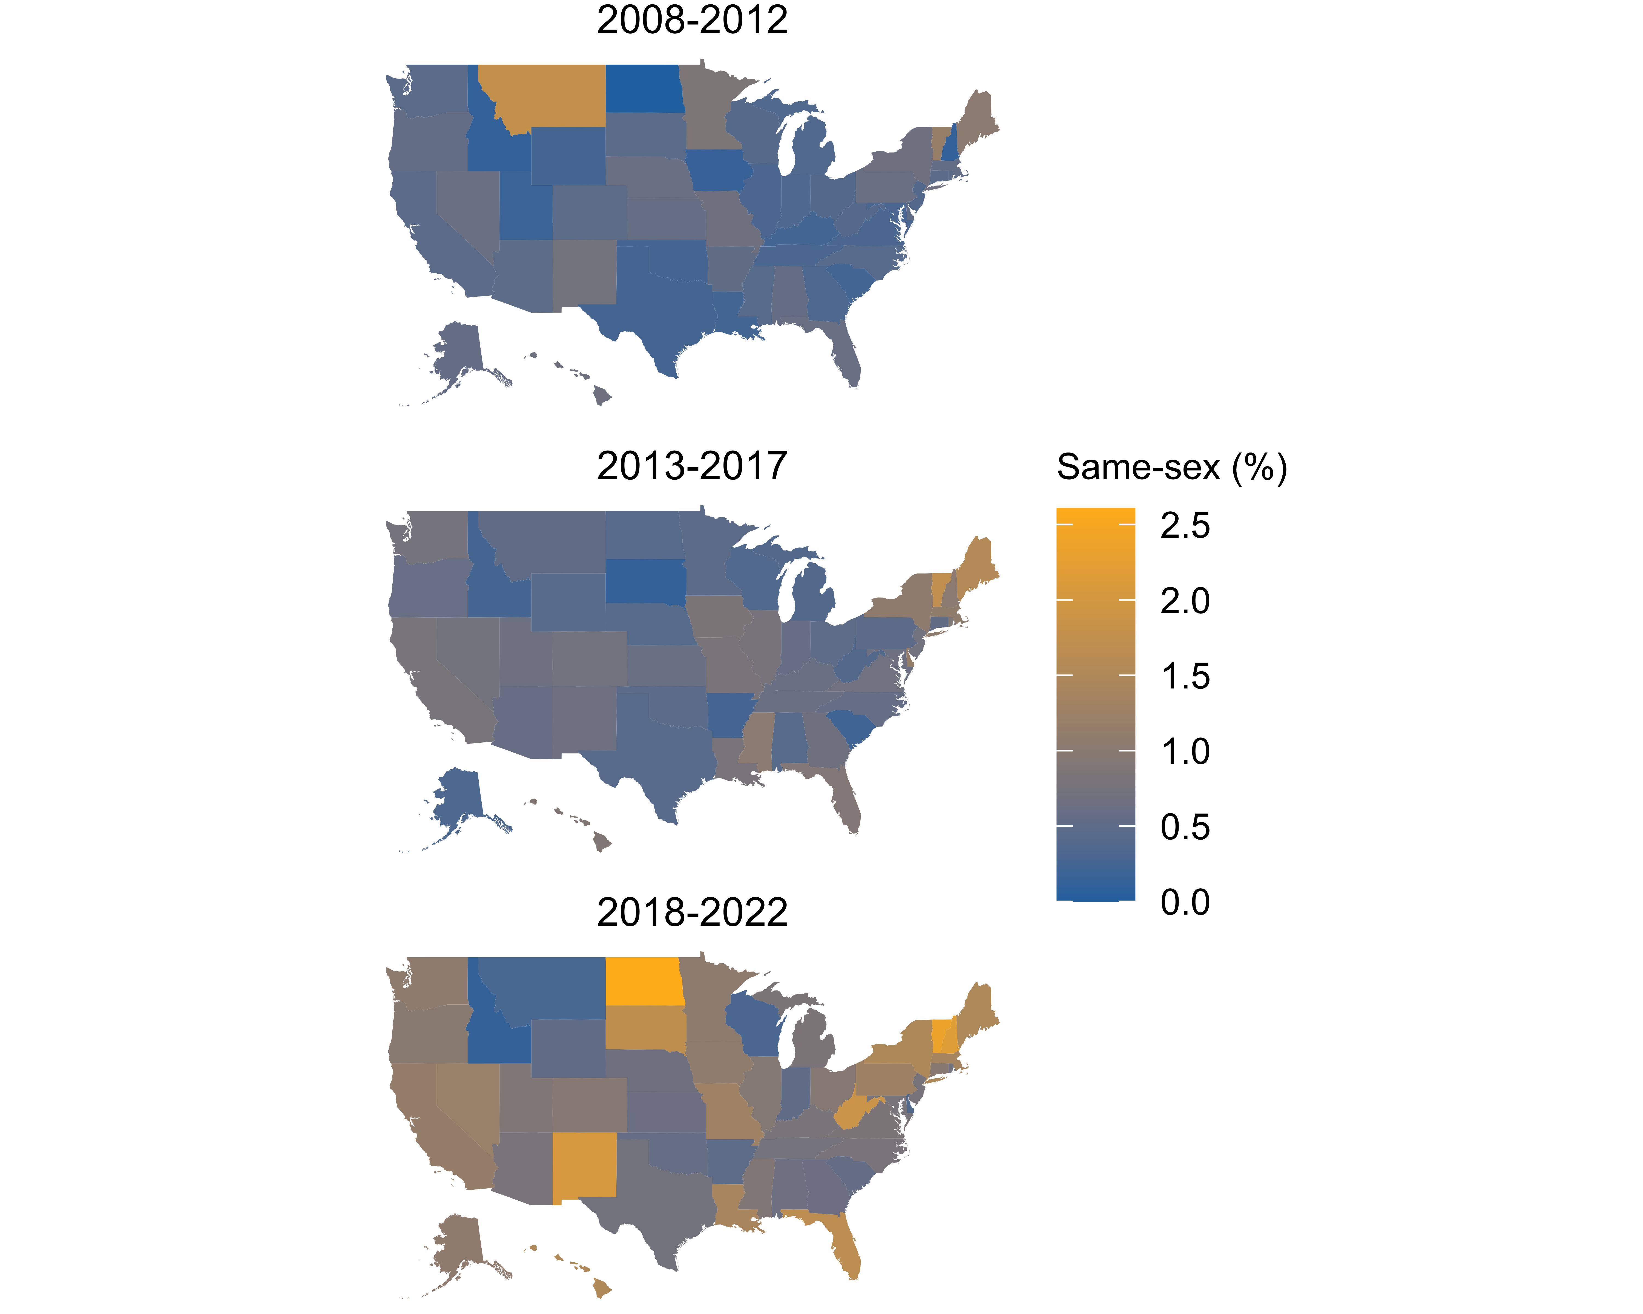

Figure 1: Percentage of cohabiting immigrants in same-sex couples in U.S. states, averaging over ACS survey years 2008 to 2022.

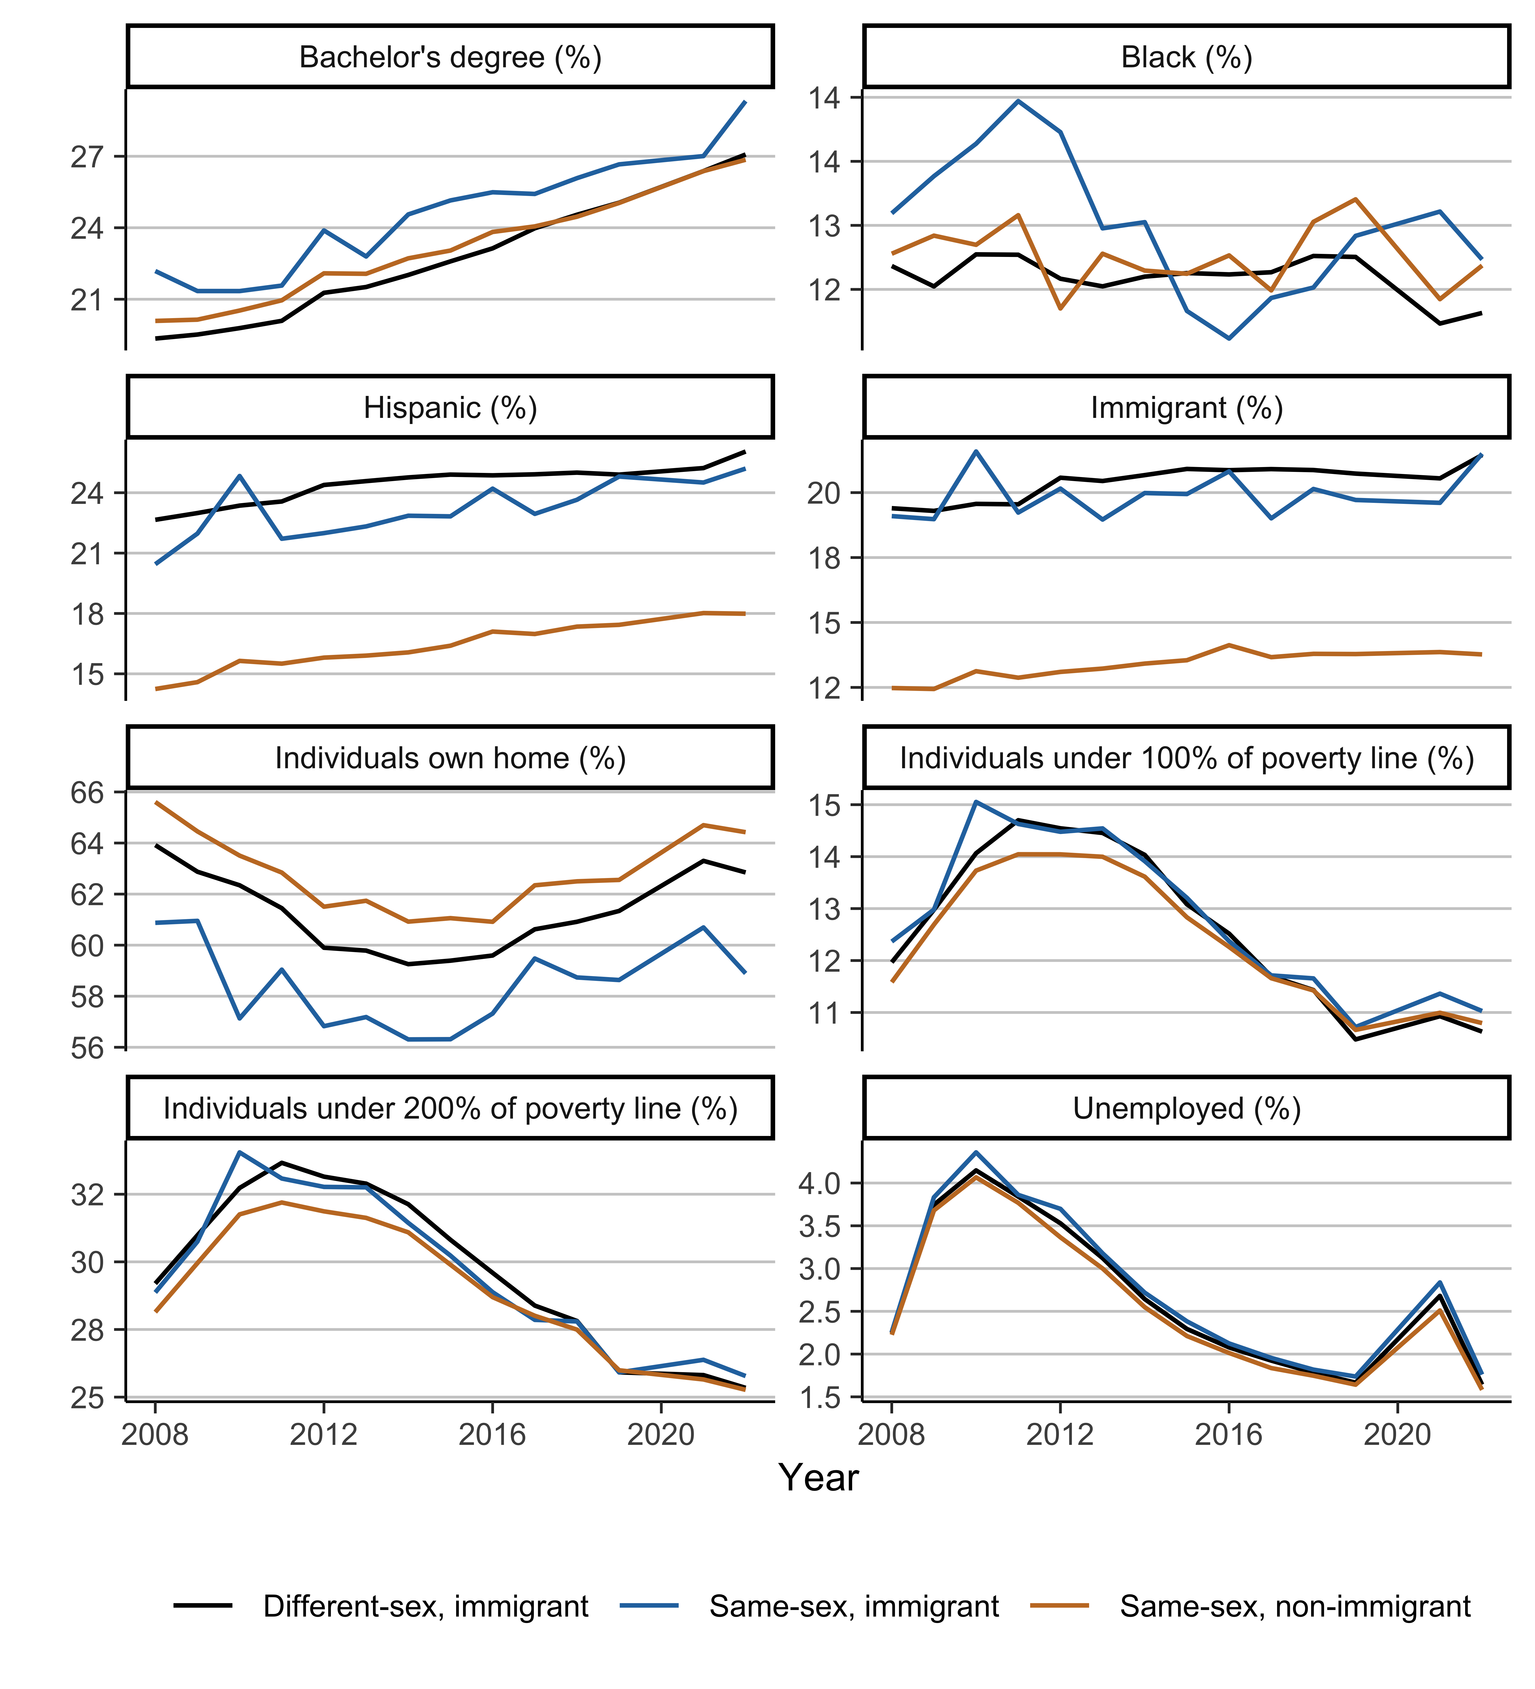

Figure 2: Geographic characteristics (percentages) over time for immigrants in different- and same-sex couples, based on American Community Survey data for 2008-2022

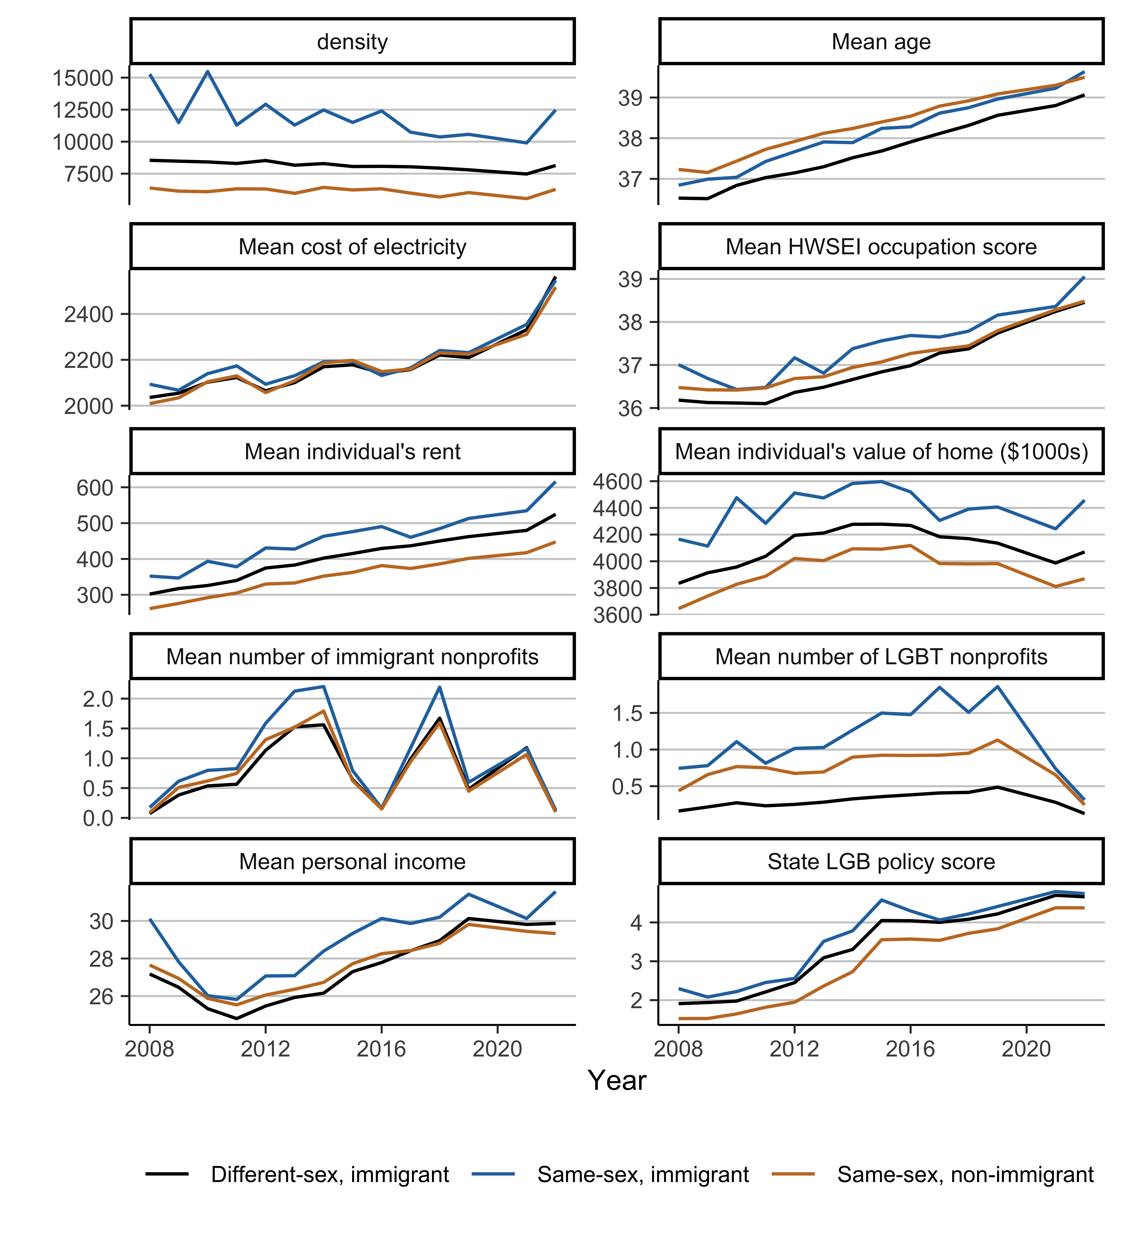

Figure 3: Geographic characteristics (means) over time for immigrants in different- and same-sex couples, based on American Community Survey data for 2008-2022

1. <https://www.lgbtmap.org/>